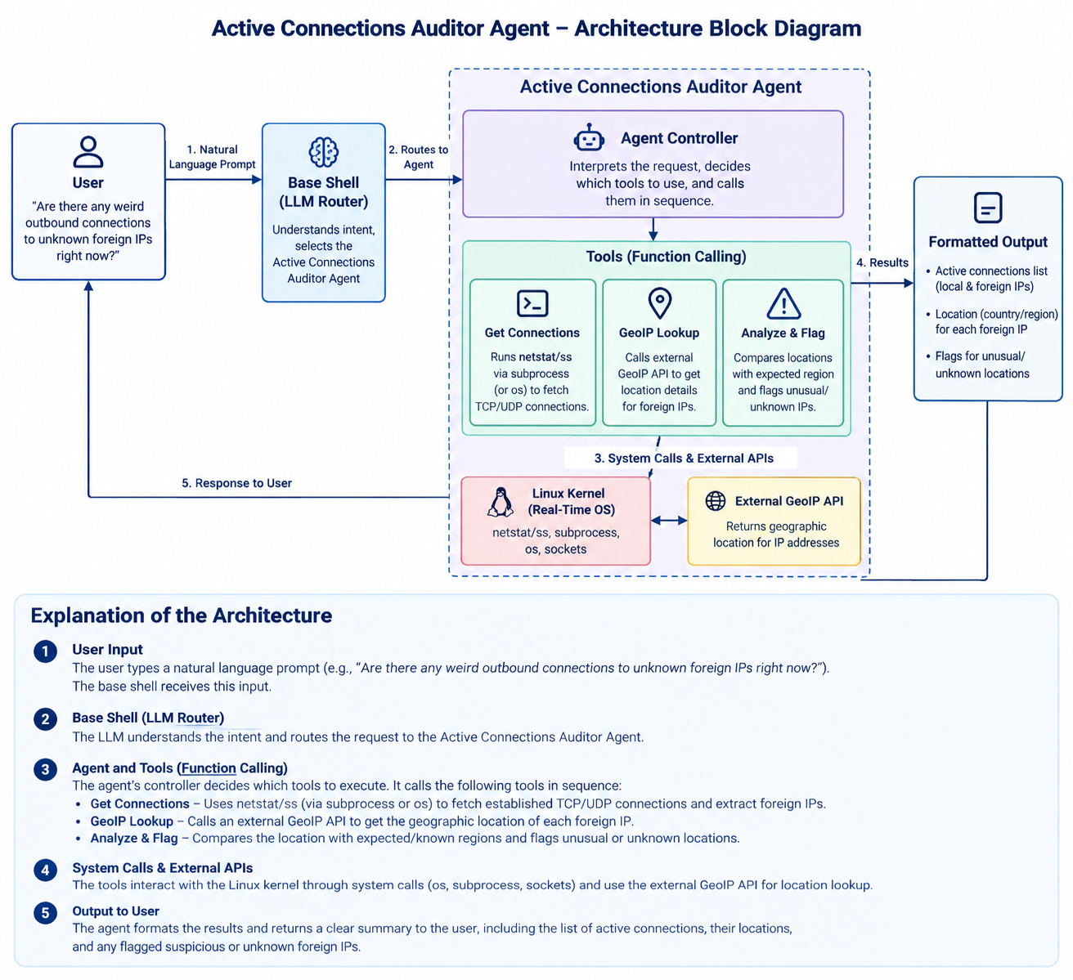

Active Connections Auditor Agent — Architecture
Your project is one specialized agent within the larger Agentic Shell. Therefore, the diagram below focuses only on the Active Connections Auditor Agent, from receiving a routed user request to identifying and reporting potentially suspicious network connections. It does not include the master shell or the other 34 agents.
1. Architecture block diagram
2. Explanation of each block
1. User Input
The user enters a natural-language query, such as “Are there any weird outbound connections to unknown foreign IPs right now?” The request is passed to the agent by the main shell.
2. Base Shell (LLM Router)
The LLM identifies the user's intent and routes the request to the Active Connections Auditor Agent. This block belongs to the overall shell architecture and is shown only to explain how your agent receives its task.
3. Agent Controller
This is the central component of your assigned agent. It interprets the task, selects the required tools, manages their execution order, and combines their results.
4. Tools (Function Calling)
The agent has three primary tools:
- Get Connections: Uses Linux commands such as ss or netstat to retrieve active network connections, including remote IP addresses, ports, protocols, and connection states.
- GeoIP Lookup: Queries an external GeoIP service to obtain the approximate country or region associated with a public IP address.
- Analyze & Flag: Examines the collected connection information and flags connections that warrant further investigation based on configured rules, unfamiliar destinations, or unexpected locations.
5. Linux Kernel (Real-Time OS)
The tools interact with the operating system through Python interfaces such as subprocess and os, or socket-related APIs where appropriate. Linux provides the actual network connection information. The agent should use read-only operations for this auditing task.
6. External GeoIP API
This service maps public IP addresses to approximate geographical locations. Private, reserved, or unresolvable IP addresses may not have useful geographic information.
7. Formatted Output
The agent presents a readable report containing:
- Active connections and their remote IP addresses.
- Protocol, port, and connection state.
- Approximate geographic locations where available.
- Connections flagged for further investigation and the reasons for each flag.
3. Overall working flow

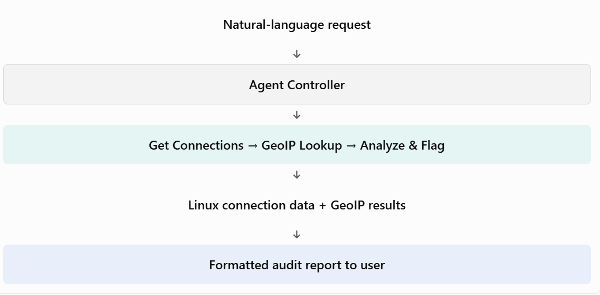
Important design consideration: A foreign IP address is not automatically malicious. Your agent should report suspicious indicators rather than declare a connection malicious based on geography alone. GeoIP results can be approximate, and the agent should distinguish observed facts from potential risks.

import ipaddress
import json
import shutil
import subprocess
import urllib.error
import urllib.parse
import urllib.request
from datetime import datetime

# --------------------------------------------------
# CONFIGURATION
# --------------------------------------------------

# Ports that may deserve review, depending on context.
# A port alone does NOT prove that a connection is malicious.
UNUSUAL_PORTS = {23, 2323, 4444, 5555, 6667}

# Limit the number of IP lookups in one run.
MAX_GEOIP_LOOKUPS = 20

# --------------------------------------------------
# TOOL 1: GET ACTIVE NETWORK CONNECTIONS
# --------------------------------------------------

def get_connections():
"""
Read current TCP/UDP socket information using Linux ss.
Returns a list of connection dictionaries.
"""

if shutil.which("ss") is None:
return {
"error": "The 'ss' command was not found. "
"Install the iproute2 package on Linux."
}

try:
result = subprocess.run(
["ss", "-H", "-tun"],
capture_output=True,
text=True,
timeout=10,
check=True
)
except subprocess.TimeoutExpired:
return {"error": "The ss command timed out."}
except subprocess.CalledProcessError as exc:
return {"error": exc.stderr.strip() or "Could not read sockets."}

connections = []

for line in result.stdout.splitlines():
fields = line.split()

# Typical fields:
# Netid State Recv-Q Send-Q LocalAddress:Port PeerAddress:Port
if len(fields) < 5:
continue

protocol = fields[0].lower()
state = fields[1].upper()
local_endpoint = fields[-2]
remote_endpoint = fields[-1]

# Ignore sockets with no remote endpoint.
if remote_endpoint in ("*", "*:*", "0.0.0.0:*", "[::]:*"):
continue

# TCP: focus on established connections.
# UDP: include connected sockets with a remote endpoint.
if protocol == "tcp" and state != "ESTAB":
continue

remote_ip = extract_ip(remote_endpoint)
if remote_ip is None:
continue

try:
parsed_ip = ipaddress.ip_address(remote_ip)
except ValueError:
continue

connections.append({
"protocol": protocol,
"state": state,
"local_endpoint": local_endpoint,
"remote_endpoint": remote_endpoint,
"remote_ip": str(parsed_ip),
"is_public": parsed_ip.is_global
})

return connections

def extract_ip(endpoint):
"""Extract an IP address from an endpoint such as 8.8.8.8:443."""

if endpoint.startswith("[") and "]:" in endpoint:
# IPv6 endpoint: [2001:4860:4860::8888]:443
return endpoint[1:endpoint.rfind("]:")]

# IPv4 endpoint: 8.8.8.8:443
# Also handles unbracketed IPv6 by removing the last port suffix.
if ":" in endpoint:
return endpoint.rsplit(":", 1)[0]

return None

# --------------------------------------------------
# TOOL 2: GEOIP LOOKUP
# --------------------------------------------------

def geoip_lookup(ip_address):
"""
Look up approximate country/region information for a public IP.
Uses the ipapi.co HTTPS endpoint.
"""

try:
parsed_ip = ipaddress.ip_address(ip_address)
except ValueError:
return {"error": "Invalid IP address"}

if not parsed_ip.is_global:
return {
"ip": ip_address,
"location": "Private or non-public address",
"country": None
}

url = "https://ipapi.co/" + urllib.parse.quote(ip_address) + "/json/"

request = urllib.request.Request(
url,
headers={"User-Agent": "ActiveConnectionsAuditor/1.0"}
)

try:
with urllib.request.urlopen(request, timeout=5) as response:
data = json.loads(response.read().decode("utf-8"))

if data.get("error"):
return {
"ip": ip_address,
"error": data.get("reason", "GeoIP lookup failed")
}

return {
"ip": ip_address,
"country": data.get("country_name"),
"region": data.get("region"),
"city": data.get("city")
}

except (urllib.error.URLError, TimeoutError, json.JSONDecodeError) as exc:
return {
"ip": ip_address,
"error": f"GeoIP lookup unavailable: {exc}"
}

# --------------------------------------------------
# TOOL 3: ANALYZE AND FLAG CONNECTIONS
# --------------------------------------------------

def analyze_connections(connections, geo_results):
"""
Flag connections that deserve review.
These are heuristic warnings, not proof of an attack.
"""

findings = []

for connection in connections:
ip = connection["remote_ip"]
reasons = []

if not connection["is_public"]:
continue

# Check remote port, if available.
remote_endpoint = connection["remote_endpoint"]
try:
remote_port = int(remote_endpoint.rsplit(":", 1)[1])
except (ValueError, IndexError):
remote_port = None

if remote_port in UNUSUAL_PORTS:
reasons.append(
f"Remote port {remote_port} is on the review list"
)

location = geo_results.get(ip, {})

if location.get("error"):
reasons.append("Geographic location could not be verified")

if not location.get("country") and not location.get("error"):
reasons.append("No country information was returned")

# Do not assume a country is suspicious just because it is foreign.
if reasons:
findings.append({
"ip": ip,
"connection": connection,
"location": location,
"reasons": reasons,
"severity": "Needs review"
})

return findings

# --------------------------------------------------
# AGENT WORKFLOW AND REPORT
# --------------------------------------------------

def run_audit():
print("\n=== ACTIVE CONNECTIONS AUDITOR ===")
print("Time:", datetime.now().astimezone().isoformat())
print("Collecting network connections...\n")

connections = get_connections()

if isinstance(connections, dict) and "error" in connections:
print("ERROR:", connections["error"])
return

print(f"Found {len(connections)} connection(s).")

# Look up each distinct public IP only once.
public_ips = list(dict.fromkeys(
c["remote_ip"] for c in connections if c["is_public"]
))

geo_results = {}

for ip in public_ips[:MAX_GEOIP_LOOKUPS]:
print(f"Looking up location for {ip}...")
geo_results[ip] = geoip_lookup(ip)

# Mark remaining IPs as not looked up.
for ip in public_ips[MAX_GEOIP_LOOKUPS:]:
geo_results[ip] = {
"ip": ip,
"error": "Lookup limit reached for this audit"
}

findings = analyze_connections(connections, geo_results)

print("\n--- CONNECTION REPORT ---")

if not connections:
print("No matching TCP/UDP connections were found.")

for index, connection in enumerate(connections, start=1):
ip = connection["remote_ip"]
location = geo_results.get(ip, {})

if not connection["is_public"]:
location_text = "Private/non-public IP"
elif location.get("country"):
location_text = location["country"]
if location.get("region"):
location_text += ", " + location["region"]
else:
location_text = location.get(
"error", "Location unavailable or not queried"
)

print(f"\nConnection {index}")
print(" Protocol:", connection["protocol"])
print(" State:", connection["state"])
print(" Local:", connection["local_endpoint"])
print(" Remote:", connection["remote_endpoint"])
print(" Location:", location_text)

print("\n--- FLAGS FOR FURTHER INVESTIGATION ---")

if not findings:
print("No connections matched the configured review rules.")
else:
for finding in findings:
print("\nIP:", finding["ip"])
print("Location:", finding["location"])
for reason in finding["reasons"]:
print(" -", reason)

print("\n--- AUDIT SUMMARY ---")
print("Connections found:", len(connections))
print("Public IPs considered:", len(public_ips))
print("GeoIP lookups attempted:",
min(len(public_ips), MAX_GEOIP_LOOKUPS))
print("Connections flagged for review:", len(findings))
print("\nAudit completed. Flags are indicators, not proof of malicious activity.")

if __name__ == "__main__":
run_audit()

tep 1 — Check that Linux is available
Open your Ubuntu terminal and run:
sudo apt update
sudo apt install iproute2
Step 2 — Check the ss command
ss -tun
This should display socket information from your Linux environment.
Step 3 — Create the Python file
mkdir -p ~/active-connections-auditor
cd ~/active-connections-auditor
nano active_connections_auditor.py
Paste the Python code into the file, then save and exit Nano using Ctrl+O, Enter, and Ctrl+X.
Step 4 — Run the agent
python3 active_connections_auditor.py
No Python package installation is required for this version.

